Jennifer Stegina

20 September 2019

CIS 250

**Unit 4 Guided Practice 2**

The following questions come from the Task examples of Chapter 13 in your textbook.

After you are finished, please submit the Microsoft Word file that contains screenshots of the SQL queries and the output, along with a comment in the query containing your name. . Your document should be named **U4_GuidedPractice2_Lastname.docx**.

(13-10) Question 1:

Join the *fruits* table and the *colors* table with an inner join. Use a join condition that matches rows when the first two columns of each table are equal.

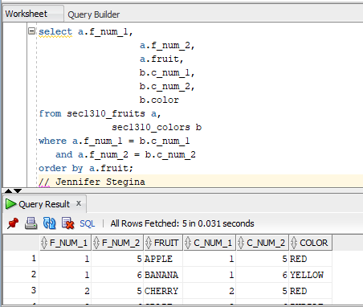

(13-11) Question 2:

Assign grades to students by placing their individual test scores within one of the grading ranges.

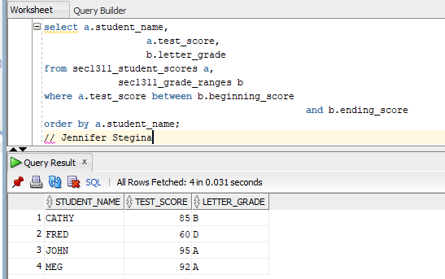

(13-12) Question 3:

Join the *bigger_numbers* table with the *smaller_numbers* table. Create a join condition that pairs each bigger number with all the smaller numbers that are less than it.

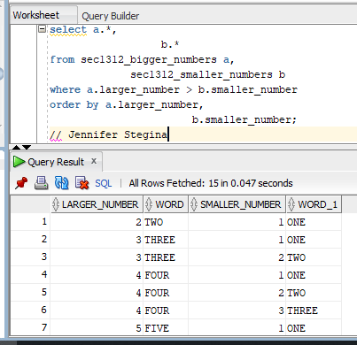

(13-14) Question 4:

Show the syntax for joining two tables in the *from* clause. Join the *fruits* table and the *colors* table as we have done before.

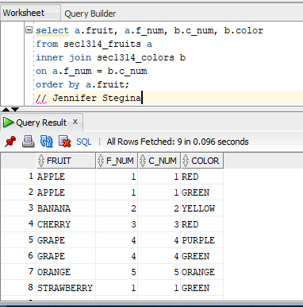

(13-15) Question 5:

For each employee show the *employee_id*, *first_name, last_name, dept_code*, and *department_name*. Sort the rows by the *employee_id*. Use an inner join to get the *department_name* from the *l_departments* table.

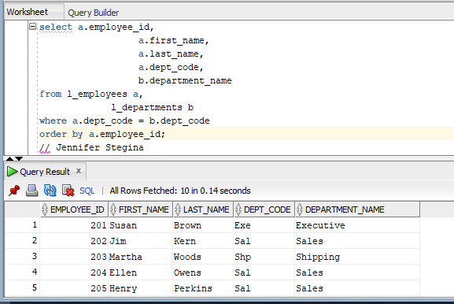

(13-17) Question 6:

List all the employees who are attending more than one lunch, except employee 208. Show the following columns: *employee_id, first_name, last_name*, and *number_of_lunches*.

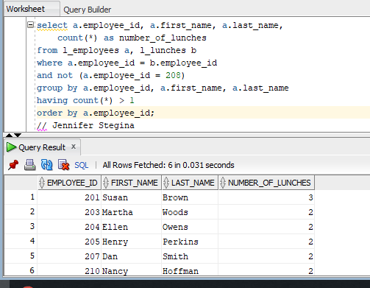

(13-18) Question 7:

Find all the columns in the primary key of the *l_foods* table.

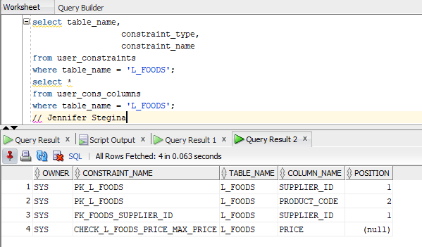

(13-19) Question 8:

Show information about all the lunches ordered by people in the shipping department. Show the employee ID, names of the employees, the lunch date, and the descriptions and quantities of the foods they will eat. Sort the result by the *employee_id* and the *lunch_date* columns. To do this you need to join four tables.

